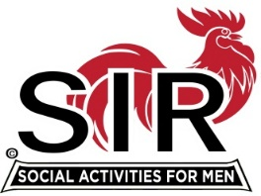

Las Trampas Branch 116
Luncheon Meeting Agenda
Nov 21, 2022, 10:30 AM

10:30 Check-in
Greeters at the door – Alan Pope
Treasurer Table – Alan Fitzgerald, Al Satake
Name Tags Table – Mike Schneider
Raffle Table – Ben Bryce

11:25 Five Minute Call
11:30 Call to order; Welcome back to all – Big SIR
Pledge of Allegiance – Al Farbman
Chaplain – Sam Beret
Sunshine Report – Matt Arena
A Story or Two – Fred Schafer

11:40 Veterans Tribute – Neil Schmidt
11:48 Branch Updates – Fred Wachowicz, Roger Craig
Holiday Party, Dec 14th Alan Pope
Welcome New Members Joe Datzman sponsored by Roger Craig
Welcome Guests Tom Welte invited by Art Donaldson, Terry Flemming and John Alonso invited by Dennis Snarr, and Om Tamulski invited by Don Schroeder

11:50 Salad Served
12:00 Lunch Served
12:10 Activity Committee Announcements – Mike Ward
12:20 Introduce Speaker, RADM (ret) Dr. Michael Baker – Al Farbman
13:05 Speaker Thank You, Little SIR - Roger Craig
13:10 Raffle Drawing – Ben Bryce
Birthday Drawing– Little SIR - Roger Craig
13:20 Sing Happy Birthday – Music – Paul King, David Williams
Sing God Bless America – Paul King, David Williams
13:25 Closing Remarks – Big SIR
13:30 Adjourn; See you at our Christmas Party on Dec 14th

